Bed and Breakfast
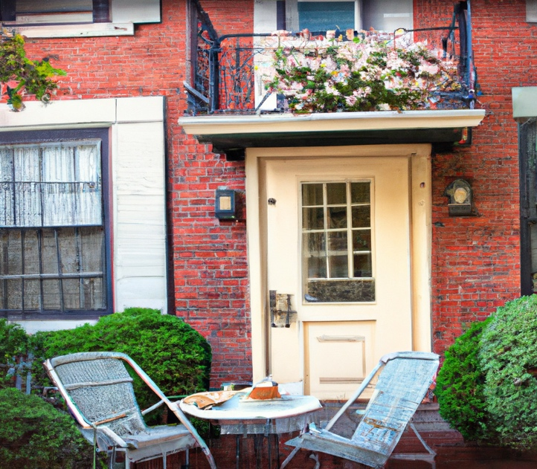 “A bed and breakfast in Boston, the style of a realistic photograph”, generated by DALL·E 2

Problem to Solve
A Bed and Breakfast (“BnB” for short!) is a short-term place one might stay and pay the owner for the service, similar to a hotel. Over the past few years, AirBnB has allowed most anyone to rent out their place, whether it’s a home, a cute cottage, or even a treehouse.
You’re a data analyst for the City of Boston and you’re interested in discovering how the rise of AirBnB has changed the local tourist scene. You’ve even compiled a database, bnb.db, filled with data directly from AirBnB. In bnb.db, whip up a few views that will paint a clearer picture of AirBnB’s influence on the city of Boston.

Distribution Code
For this problem, you’ll need to download bnb.db, along with a few .sql files in which you’ll write your queries.

Schema
receives
has
Listing
Review
Availability
Within bnb.db, you’ll find three tables that implement the relationships described in the ER diagram above. Click the drop-downs below to learn more about the schema of each table.

listings table
The listings table contains the following columns:
- id, which is the ID of the listing.
- property_type, which is the type of the listing (e.g., “Entire rental unit”, “Private room in rental unit”, etc.).
- host_name, which is the AirBnB username of the listing’s host.
- accommodates, which is the listing’s maximum number of occupants.
- bedrooms, which is the listing’s number of bedrooms.
- description, which is the description of the listing on AirBnB.

reviews table
The reviews table contains the following columns:
- id, which is the ID of the review.
- listing_id, which is the ID of the listing which received the review.
- date, which is the date the review was posted.
- reviewer_name, which is the AirBnB username of the reviewer.
- comments, which is the content of the review.

availabilities table
The availabilities table contains the following columns:
- id, which is the id of the availability.
- listing_id, which is the listing ID associated with the availability.
- date, which is the date of the availability.
- available, which is whether the date is still available to be booked (TRUE or FALSE).
- price, which is the price of staying on the given date.

Specification
In each of the corresponding .sql files, write a SQL statement to create each of the following views of the data in bnb.db. Note that, while views can be created from other views, each of your views should stand alone (i.e., not rely on a prior view).

No Descriptions
You might notice that when running
SELECT * FROM "listings" LIMIT 5;
the results look quite wonky! The description column contains descriptions with many line breaks, each of which are printed to your terminal.
In no_descriptions.sql, write a SQL statement to create a view named no_descriptions that includes all of the columns in the listings table except for description.

One-Bedrooms
In one_bedrooms.sql, write a SQL statement to create a view named one_bedrooms. This view should contain all listings that have exactly one bedroom. Ensure the view contains the following columns:
- id, which is the id of the listing from the listings table.
- property_type, from the listings table.
- host_name, from the listings table.
- accommodates, from the listings table.

Available
In available.sql, write a SQL statement to create a view named available. This view should contain all dates that are available at all listings. Ensure the view contains the following columns:
- id, which is the id of the listing from the listings table.
- property_type, from the listings table.
- host_name, from the listings table.
- date, from the availabilities table, which is the date of the availability.

Frequently Reviewed
In frequently_reviewed.sql, write a SQL statement to create a view named frequently_reviewed. This view should contain the 100 most frequently reviewed listings, sorted from most- to least-frequently reviewed. Ensure the view contains the following columns:
- id, which is the id of the listing from the listings table.
- property_type, from the listings table.
- host_name, from the listings table.
- reviews, which is the number of reviews the listing has received.
If any two listings have the same number of reviews, sort by property_type (in alphabetical order), followed by host_name (in alphabetical order).

June Vacancies
In june_vacancies.sql, write a SQL statement to create a view named june_vacancies. This view should contain all listings and the number of days in June of 2023 that they remained vacant. Ensure the view contains the following columns:
- id, which is the id of the listing from the listings table.
- property_type, from the listings table.
- host_name, from the listings table.
- days_vacant, which is the number of days in June of 2023, that the given listing was marked as available.

Usage
To test your views as you write them in your .sql files, you can run a query on the database by running
.read FILENAME
where FILENAME is the name of the file containing your SQL query. For example,
.read no_descriptions.sql
Keep in mind you can also use
DROP VIEW name;
where name is the name of your view, to remove a view before creating it anew.

How to Test
While check50 is available for this problem, you’re encouraged to also test your code on your own. You might try queries like the below:
- How many listings are there in total? Use your no_descriptions view to find that there are 3,973.
- How many one-bedroom listings are there? And how many can accommodate at least 4 guests? Use your one_bedrooms view to find that of the 1,228 one-bedrooms, 222 of them can accommodate your group of 4.
- How many listings have availability for December 31st, 2023 (i.e., “2023-12-31”)? Use your availableview to find that there are 2,251. How many of those are available on any type of boat? You should find that there are 7. Enjoy your New Year’s Eve afloat!
- How many reviews does the most frequently reviewed property have? And who is the host of that property? Use your frequently_reviewed view to find that Tiffany’s property has 860 reviews.
- How many listings were available in June 2023? Use your june_vacancies view to find that there were 1,895 vacancies.

